Predictive Analysis Group 3

Step1: Choosing the variables



|  |
| --- |
| DATA_USED_1MONTH |
| DATA_3MONTH_TO_DEACT |
| NUM_IVR_CALLS |
| AVG_IVR_DURATION |
| CALL_3MONTHS_TO_DEACT |
| CALLS_1MONTH |
| NUM_DROPPED_CALLS |
| tenure |
| total_drop_calls |
| hh_income |

Step2: SAS code

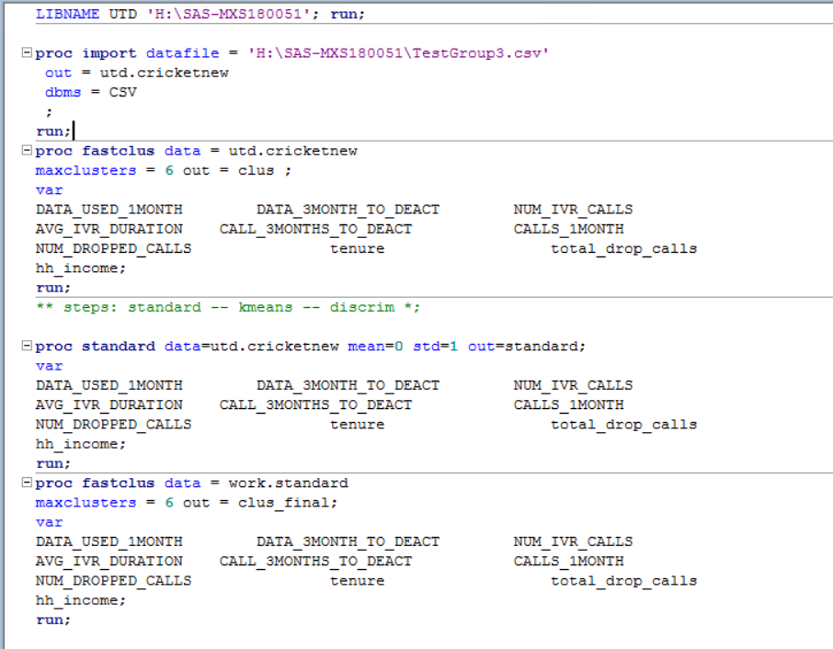

In the above code, I have tested with creation of 6 clusters using the above-mentioned variables.

Step a: Setting LIBNAME

Step b: Cluster declaration with given variables

Step c: Standardizing the variables to proper mean and std deviation,

Step d: merged the cluster data with actual data as clus_final



Sas Code



.